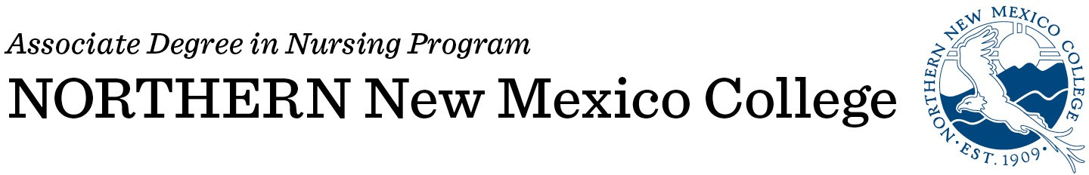

Please type information:
Date:

Name: | Banner ID:
First Middle Last
DOB:
Previous or other names:
Mailing Address: | Contact Numbers:
Address | Home
City State Zip Code | Cell
Personal Email: | Work
Northern New Mexico College Email:

*Please note you will need a NNMC email address in order to receive emails and correspondence

Name and telephone number of emergency contact person:

Name:
Telephone number:

- I am aware that I must have achieved “regular” Admission to NNMC to be considered for the Nursing Program. I understand that filing this form does not guarantee acceptance in the Nursing Program. I am aware of the deadline dates on this packet and that this form is only valid for fall 2022 entry.
- Do you speak English as a second language? (i.e. is a language other than English your first language?)

CERTIFICATION
I hereby certify that all statements on the application and essay are correct to the best of my knowledge. I understand that falsifications or omissions of information may result in disqualification or dismissal of this application to the Northern New Mexico College Associate Degree Nursing Program.
Application materials submitted as part of the application process become the property of the NNMC ADN Program and will not be returned. Please keep a copy of the entire application packet for your records.

Signature: | Date:

Please send completed application packet to Ms. Denise Martinez Arevalo at denise.arevalo@nnmc.edu

